2022 Unit 3_4 Chemistry trial exam

Name: ____________________

Section A: Multiple Choice section

Use the following information to answer Questions 1 and 2.
A particular gas-fired power plant is rated as 52.0% efficient. The plant is a cogeneration one that uses both expansion of hot gases and the conversion of water to steam to produce electrical energy. For this question assume that the gas used is 100% methane.

Question 1
The mass of methane required to generate 1.00 MJ of energy in this plant will be, in g,
A. 18.0
B. 34.6
C. 40.0
D. 54.0

Question 2
The volume of CO₂ produced at 200 ºC and 100 kPa in the production of 1.00 MJ of energy will be, in L,
A. 44.2
B. 53.0
C. 85.0
D. 98.4

Question 3
As the length of an alkane molecule gets longer, the
A. energy density drops but the molar heat of combustion increases.
B. intramolecular forces become stronger making the melting point higher.
C. viscosity of the molecule will increase and the boiling point decrease.
D. dispersion forces become stronger, leading to a higher energy density.

Question 4
Petrodiesel produced from canola crops presents less problems in cold climates than petrodiesel formed from waste animal fat. The main reason for this is
A. the fatty acids in plants are more likely to go rancid and degrade to other compounds.
B. the fatty acids in plants are likely to be significantly shorter than those from animals.
C. the dispersion forces in plant fatty acids are likely to be stronger than those of animal fatty acids.
D. the plant fatty acids are likely to be unsaturated and to have a lower melting point.

Question 5
An energy profile diagram is shown below. New graph
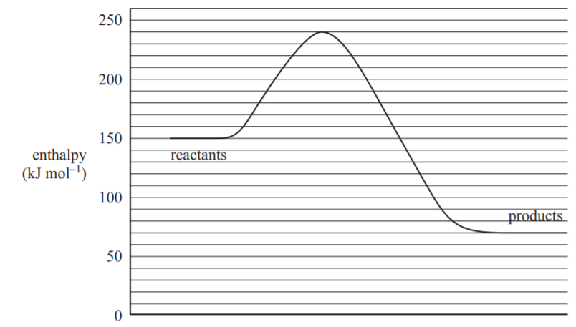

Which alternative correctly shows the activation energy and the value of ∆H of the reverse reaction?
A. +90 kJ mol⁻¹ and -70 kJ mol⁻¹
B. +90 kJ mol⁻¹ and -170 kJ mol⁻¹
C. +170 kJ mol⁻¹ and +90 kJ mol⁻¹
D. +170 kJ mol⁻¹ and -90 kJ mol⁻¹

Question 6
For the decomposition of NOCl, the reversible reaction is

2NOCl(g) ⇌ 2NO(g) + Cl₂(g) K_{c} = 1.2 × 10⁻⁵ M at 30 ºC

In an equilibrium mixture at 30 ⁰C,
A. the [NOCl] = [NO].
B. the [NO] is likely to be much less than [NOCl].
C. the [NOCl] will be double [Cl₂].
D. the [NO] will be greater than [NOCl].

Question 7
The OCl⁻ ion forms an equilibrium with water. The equation is

OCl⁻(aq) + H₂O(l) ⇌ HOCl(aq) + OH⁻(aq)

If a few drops of HCl are added to an equilibrium mixture of OCl⁻
A. the value of K_{c} will change.
B. there is no change to the equilibrium as the equation does not contain HCl.
C. the pH will be higher than it was as the forward reaction is favoured.
D. the pH will be lower than it was once equilibrium is re-established.

Question 8
The addition of an inert gas makes no impact on the position of equilibrium in a gaseous mixture. The best explanation for this is that
A. the volume of the container and the partial pressure of each species has not changed.
B. the increased pressure of the extra particles compensates the lower number of collisions.
C. the rate of the forward and back reactions both decrease by the same amount.
D. the particles of inert gases are much smaller than the reacting particles.

Question 9
A Maxwell-Boltzmann curve is shown below:
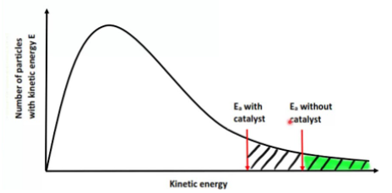
This graph could be best used to illustrate
A. the impact of temperature on the average kinetic energy of particles.
B. the impact of the use of a catalyst on the proportion of particles with sufficient energy to react.
C. the proportion of particles with sufficient kinetic energy to react at different temperatures.
D. the impact of a catalyst on the average speed of particles in a reaction.

Use the following information to answer questions 10 and 11
An iron ion half cell is used to form a series of galvanic cells, as shown below.
For this question, assume all solutions are 1.0 M and the temperature is 25 ºC.
voltmeter
Fe³⁺(aq)/
Fe²⁺(aq)

Na⁺(aq)

Mg²⁺(aq)
platinum electrode
Question 10
Which of the following half-cells would produce the largest voltage when connected to the half-cell shown?
A. I₂/I⁻
B. Cu²⁺/Cu
C. Au⁺/Au
D. H⁺/H₂

Question 11
This cell is connected to a Fe²⁺/Fe cell. When this happens,
A. no reaction will occur as both cells are the same.
B. Fe²⁺ forms in one cell and Fe metal in the other.
C. a power supply will need to be used to cause a reaction to occur.
D. the concentration of Fe²⁺ will increase in both half-cells.

Question 12
Electricity can be produced by burning methane in a generator or by reacting it in a fuel cell.
A. Both these methods are a form of galvanic cell.
B. Burning methane in a generator will have the same efficiency as a fuel cell.
C. The fuel cell method is better as it does not produce any emissions.
D. The overall reaction is the same in both cases.

Question 13
A galvanic cell can be constructed between an iron half-cell and a zinc half-cell. Despite this being technically feasible, there is little commercial interest in such a battery. The most likely reason for the lack of interest is that
A. solutions of both metals are too insoluble to form half-cells.
B. the voltage produced would be too low to be practical.
C. the toxicity of both metals is too high to use safely.
D. iron metal rusts too easily.

Question 14
The half-equation occurring at the anode of an acidic methane fuel cell is
A. CH₄(g) + 2H₂O(g) CO₂(g) + 8H⁺(aq) + 8e
B. CH₄(g) + 2H₂O(g) CO₂(g) + 4H⁺(aq) + 4e
C. CH₄(g) + 4OH⁻(g) CO₂(g) + 4H₂O(l) + 8e
D. CH₄(g) + 2O₂(g) CO₂(g) + 2H₂O(l)

Question 15
The electrolyte in a cell is 0.1 M HCl. The products of electrolysis of this solution will be
A. hydrogen gas at the anode and chlorine gas at the cathode.
B. oxygen gas at the anode and chloring gas at the cathode.
C. hydrogen gas at the cathode and oxygen gas at the anode.
D. hydrogen gas at the anode and oxygen gas at the cathode.

Question 16
Which of the following will produce the highest mass of aluminium in an electrolytic cell?
A. 10 amps running for 4 hours through 1.0 M Al(NO₃)₃
B. 100 amps running for 1 hour through 1.0 M Al(NO₃)₃
C. 100 amps running for 5 minutes through AlCl₃(l)
D. 10 amps running for 1 hour through AlCl₃(l)

Question 17
Consider the molecule drawn below
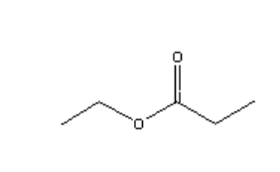
This molecule could be formed from the reaction between
A. ethanoic acid and propan-1-ol.
B. ethanol and propanoic acid.
C. ethanol and ethanoic acid.
D. propan-1-ol and propanoic acid.

Question 18
The IUPAC name of the molecule shown is
A. 1-chloropentan-4-ol
B. 1-chloro-4-hydroxypentane
C. 5-chloropentanol
D. 5-chloropentan-2-ol

Question 19
Which one of the following molecules can form cis and trans isomers?
A. CH₂CHClCH₂Cl
B. CH₃CHClCHCH₂
C. 3,4-dibromohex-3-ene
D. 1,1-dibromohex-1-ene

Question 20
A chemical reaction produces a colour change and a product that produces a gas when added to Na₂CO₃. The chemical reaction could have been
A. propene and chlorine gas
B. ethanol and propanoic acid
C. propan-2-ol and acidified Cr₂O₇²⁻
D. propan-1-ol and acidified Cr₂O₇²⁻

Question 21
Consider the ¹H NMR shown below.
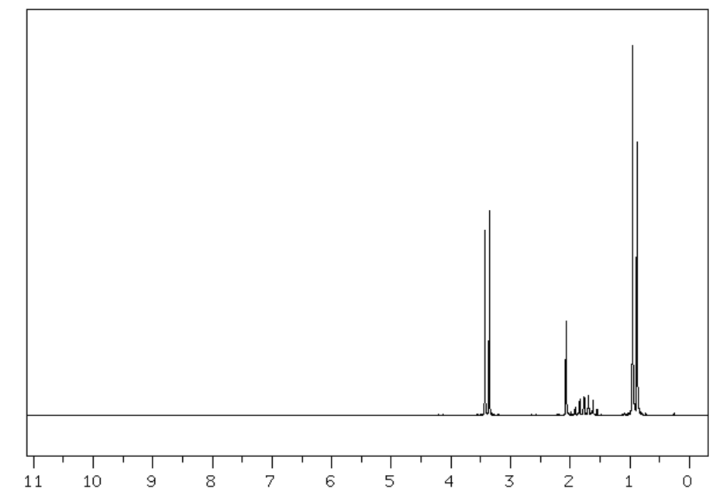
The molecule producing this NMR could be
A. 2-methylpropan-1-ol
B. propan-1-ol
C. butan-1-ol
D. 2-methylpropan-2-ol

Use the following diagram to answer Questions 22 and 23
A titration is performed to determine the concentration of a benzoic acid solution. The structure of benzoic acid is drawn below.

A 20.0 mL solution of benzoic acid is diluted carefully to 100 mL with deionised water. The mean titre determined when 20.0 mL aliquots of the diluted solution were titrated against 0.120 M NaOH was 14.6 mL.

Question 22
The concentration of the original benzoic acid solution is, in M,
A. 0.0438 M
B. 0.0876 M
C. 0.219 M
D. 0.438 M

Question 23
The mass of benzoic acid present in the original solution is, in g,
A. 0.213
B. 0.53
C. 1.07
D. 1.22

Question 24
A skeletal structure of a molecule is shown below:

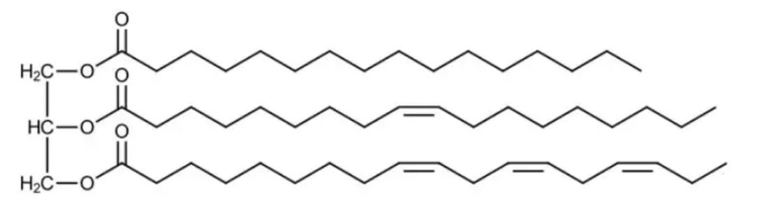
Consider the following categories to select the correct answer:

I fatty acid II triglyceride III monounsaturated fat IV polyunsaturated fat V ester

Which alternative shows all the categories that this molecule belongs to?
A. I, III and V
B. II, III, IV and V
C. II, IV and V
D. I, II, IV and V

Question 25
A correct ranking for solubility in water, from least soluble to most, for the following polysaccharides is
A. cellulose, amylopectin, amylose, glycogen
B. cellulose, amylose, amylopectin, glycogen
C. glycogen, cellulose, amylopectin, amylose
D. glycogen, amylopectin, amylose, cellulose

Question 26
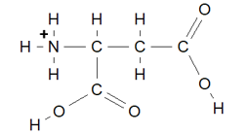

The molecule above is
A. aspartic acid in neutral conditions.
B. aspartic acid in solution of pH 12.
C. aspartic acid zwitterion.
D. aspartic acid in solution of pH 2.

Question 27
A soft drink manufacturer swaps the 36 g of sugar in a can of soft drink for 36 g of aspartame. It is likely that a consumer of the new soft drink will
A. notice very little difference between either drink.
B. have a much lower energy intake but notice little difference in taste.
C. have a similar energy intake but find the drink unpleasantly sweet.
D. have a much higher energy intake without much change in sweetness.

Question 28
The structure of one of the vitamins is shown below.
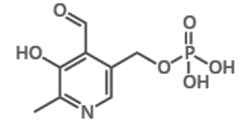

It is likely that this vitamin is
A. insoluble in water and stored in adipose tissue.
B. insoluble in water and not stored in the body.
C. soluble in water and made in the human body.
D. soluble in water and essential in our diets.

Use the following information to answer Questions 29 and 30
The apparatus below is used to measure the energy content of various food samples. In one particular test a 0.46 g sample of nut causes the temperature of 12 g of water to increase by 8.0 ºC.
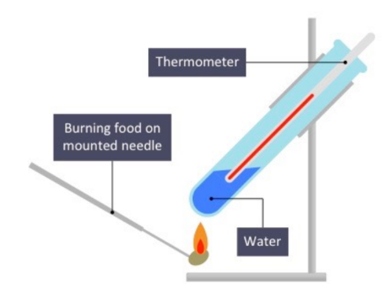

Question 29
The energy content of the nut, in kJ g⁻¹, is
A. 0.40
B. 0.87
C. 1.40
D. 870

Question 30
The thermometer used is observed to have a bubble in the liquid that means every temperature reading is exactly
2 ⁰C higher than the real temperature. The impact of this issue is
A. to make all measurements useless.
B. to provide incorrect temperature readings but correct energy content values.
C. to provide incorrect temperature readings leading to high energy content values.
D. to provide incorrect temperature readings and less precise results.

Section B: Short answer questions
Question 1 (9 marks)
The diagram below is of a crude oil fractionating column and the products that can be collected from it.

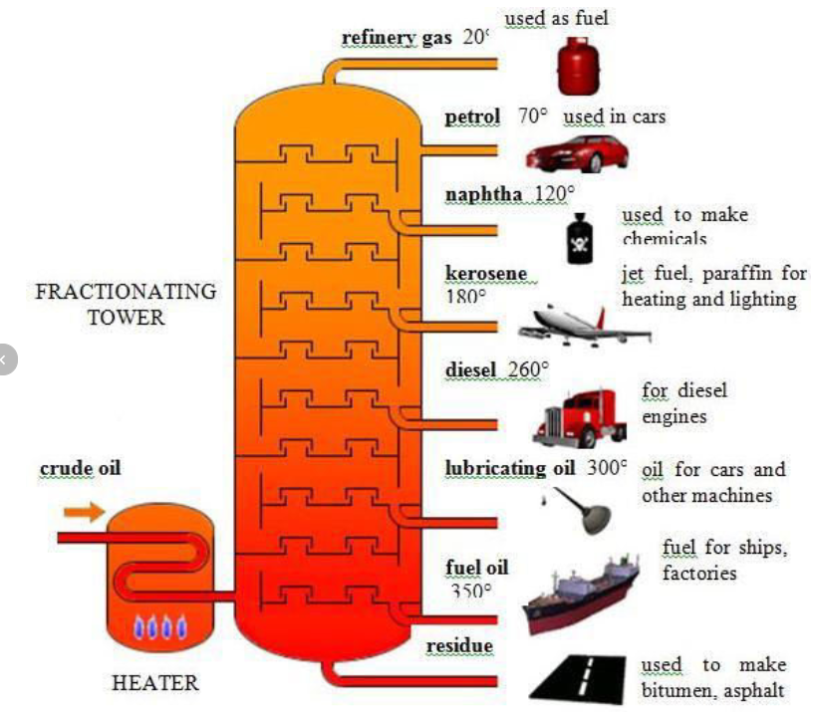

a. i. Crude oil is described as a fossil fuel. What is a fossil fuel? 1 mark

___________________________________________________________________________________

ii. How extensive are Australia’s reserves of crude oil? 1 mark

___________________________________________________________________________________

b. Explain how petrol and petrodiesel are separated in this column. 2 marks

___________________________________________________________________________________

___________________________________________________________________________________

c. In a comparison of petrol with petrodiesel, which of the two fuels will have-

i. the lower flashpoint ____________________________ 1 mark

ii. the greater viscosity ____________________________ 1 mark

iii. explain the viscosity difference between petrol and diesel. 2 marks

___________________________________________________________________________________

___________________________________________________________________________________

d. Crude oil usually contains a low concentration of sulfur.
Write a balanced equation for the reaction of sulfur when crude oil undergoes combustion. 1 mark

________________________________________________________________________________________

Question 2 (9 marks)
Amongst the many batteries being trialled at the moment is the iron-nickel battery. Its energy density and tolerance of recharging make it a possible alternative to the current lead-acid car battery. The voltage produced by this battery is 1.4 V. The reaction in the cell is between iron metal and nickel oxyhydroxide, NiOOH. A sketch of the cell is shown below.
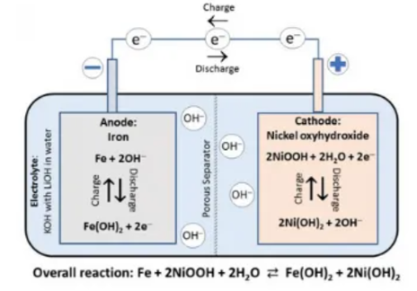

Overall equation: Fe(s) + 2NiOOH(aq) + 2H₂O(l) Fe(OH)₂(s) + 2Ni(OH)₂(aq)
a. Use the labels provided to write the half-equations for the reactions occurring when this cell discharges.
Also list the element changing oxidation number and the change occurring. 4 marks

Anode: _______________________________________________ Ox. number change ___________

Cathode: _______________________________________________ Ox. number change ___________

b. Determine the standard electrode potential of the nickel oxyhydroxide.
(Assume the iron half-equation in the Data Book is applicable) 1 mark

______________________________________________________________________________________

c. Use the circles provide on the diagram to indicate the polarity of the electrodes during discharge. 1 mark

d. Explain how this battery is recharged (in terms of voltage and polarity). 2 marks

______________________________________________________________________________________

______________________________________________________________________________________

e. State one difference between this cell and a fuel cell. 1 mark

______________________________________________________________________________________

Question 3 (8 marks)
Ammonia is produced from the reversible reaction between nitrogen and hydrogen gases. The equation for the reaction is:

N₂(g) + 3H₂(g) ⇄ 2NH₃(g) ∆H = -ve

a. A manufacturer wishes to make 60 mole of ammonia, so he adds 30 mole of nitrogen and 90 mole of hydrogen to
a reactor. Will this work? Justify your answer. 2 marks

___________________________________________________________________________________________

____________________________________________________________________________________________

b. A temperature change is made to a system at equilibrium. The change causes the amount of hydrogen to
increase by 0.12 mole.

i. By how much did the amounts of the other chemicals change? 2 marks

N₂ change: _______________ NH₃ change: __________________

ii. Was the temperature increased or decreased? 1 mark

_______________________________________________________________________________________

iii. What is the impact of the temperature change on the rate of the forward reaction? 1 mark

________________________________________________________________________________________

c. The volume of an equilibrium mixture of the above gases is halved.
i. When the volume is halved, does the concentration of each gas change by the same amount? Justify your
answer. 1 mark

_______________________________________________________________________________________

ii. The volume drop will favour the forward reaction. When the system establishes equilibrium again, will the
concentration of nitrogen gas be higher or lower than it was before the volume change? 1 mark

________________________________________________________________________________________

Question 4 (9 marks)
a. A sample of but-1-ene is heated strongly with hydrochloric acid gas, HCl.
It is noticed that two different products form.
i. Write a balanced equation for the reaction occurring. 1 mark

______________________________________________________________________________________

ii. Draw and name the products formed. 2 marks

b. An alcohol containing four carbon atoms is heated strongly with a Cr₂O₇²⁻ solution in acid conditions .
After prolonged heating it is observed that the alcohol has not reacted.
Draw and name the alcohol. 2 marks

c. A sample of methane is heated with excess Cl₂ with UV light as a catalyst. A number of products are formed.
Draw three of the products. 3 marks

d. Draw a molecule containing two carbon atoms that will have optical isomers. 1 mark

Question 5 (6 marks)
a. The compounds lactose and lactase are both found in milk. Explain the difference in structure and function of
these two substances. 3 marks

________________________________________________________________________________________

________________________________________________________________________________________

________________________________________________________________________________________

________________________________________________________________________________________

b. In some processes, lactase is hydrolysed and in others it is denatured. Explain, with reference to chemical
bonding, the difference between these two processes. 3 marks

________________________________________________________________________________________

________________________________________________________________________________________

________________________________________________________________________________________

________________________________________________________________________________________
Question 6 (11 marks)
A sample of an organic compound is tested to try and deduce its structure. Its empirical formula is C₂H₅O.
The mass spectrum of the compound, labelled as molecule X, is shown below.
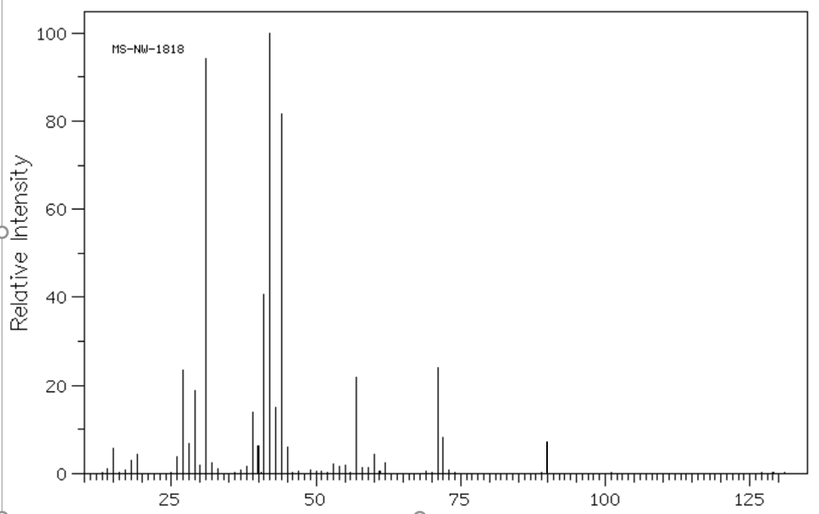 m/z

i. Determine the molecular formula of molecule X. 1 mark

__________________________________________________________________________________

ii. There is a significant peak with a m/z ratio of 31. Suggest a fragment that might have caused this peak.

______________________ 1 mark

b. The infrared spectrum of the unknown compound is shown below.
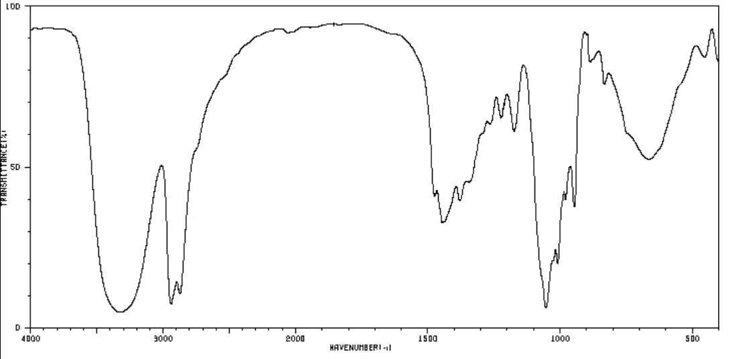

Suggest two useful conclusions that can be drawn from this spectrum. Justify each conclusion.
2 marks
___________________________________________________________________________

____________________________________________________________________________

c. Draw two possible isomers that match the molecular formula and the information provided so far. 2 marks

d. The ¹H-NMR and ¹³C-NMR spectra for the unknown compound are both shown below.
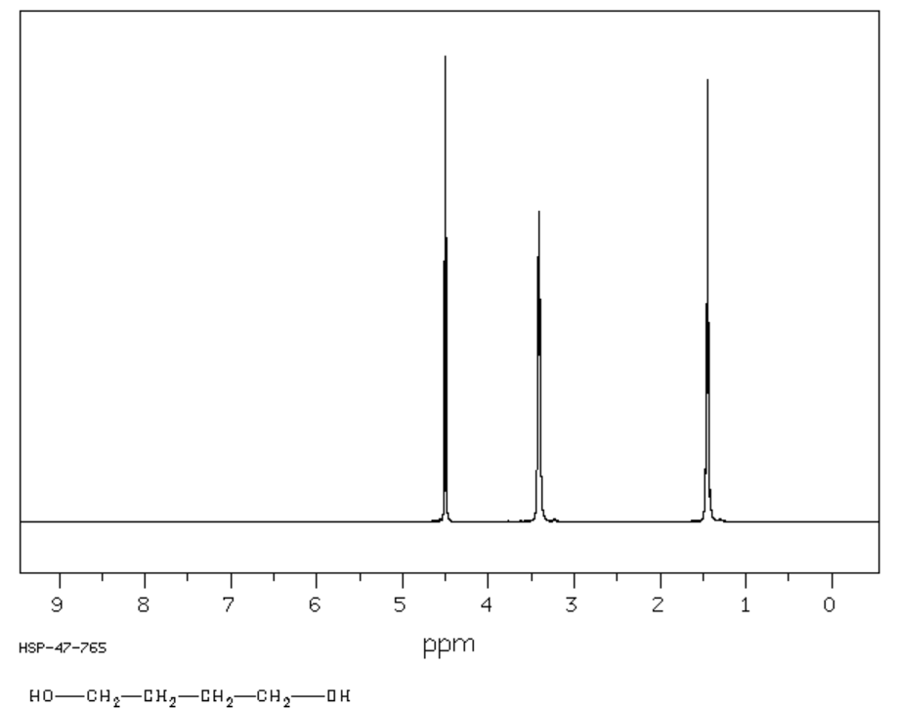
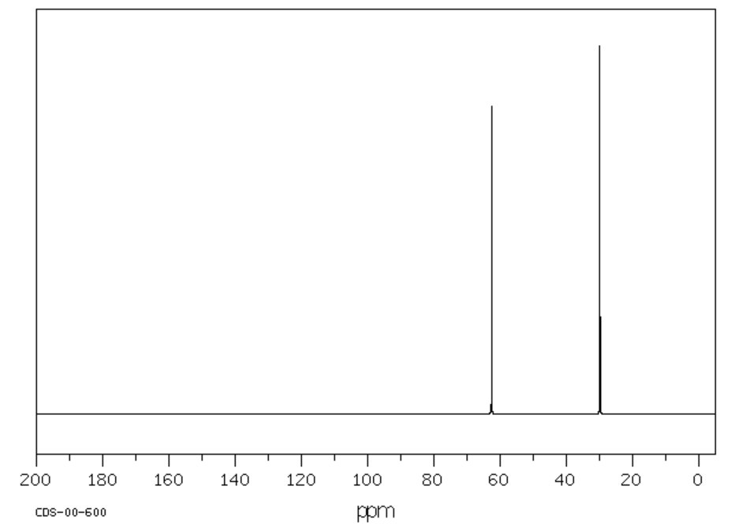
Combine all the data provided to draw the structure of the compound. Explain how the NMR
data supports your conclusion. Include the IUPAC name of the compound. 4 marks

__________________________________________________________________________

__________________________________________________________________________

__________________________________________________________________________

___________________________________________________________________________

____________________________________________________________________________

Question 7 (10 marks)
The diagram below is from an old text and it is describing the production of lithium metal in a laboratory.
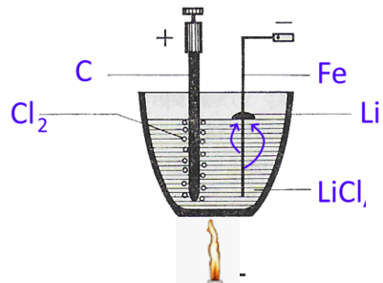

a. The electrolyte in the crucible is labelled as LiCl but it is not LiCl(aq).
i. Describe the electrolyte being used and how it is prepared. 2 marks

_______________________________________________________________________________________

_______________________________________________________________________________________

ii. What products would form if LiCl(aq) was the electrolyte? 2 marks

Anode: _____________________________ Cathode: ____________________________

b. Write balanced half-equations for the reactions that will occur in the crucible shown. 2 marks

Anode: ___________________________ Cathode: ______________________________________

c. The diagram shows a different material is used for each electrode.
What unwanted half-equation would occur if both electrodes were iron? 1 mark

_____________________________________________________________________________________

d. A current of 3.10 amps is passed through the cell for 20.0 minutes. Calculate the volume of chlorine gas that
would be collected from this cell if the gas pressure is 150 kPa and the gas temperature 420 ºC. 3 marks

_______________________________________________________________________________________

_______________________________________________________________________________________

_______________________________________________________________________________________

_______________________________________________________________________________________

Question 8 (10 marks)
The diagram below if from a Health textbook to aid in the understanding of the digestion process. Use this diagram to help answer the questions below.
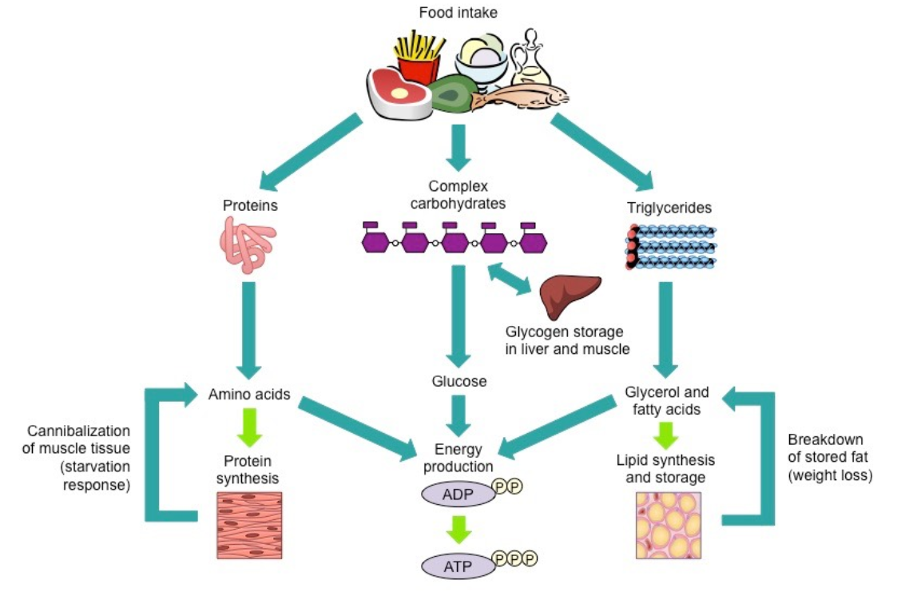
a. Milk contains casein protein. When we consume milk, our digestive system will break this protein down.

i. Name the bond that links the building blocks in proteins. _____________________________ 1 mark

ii. What category of reaction is this first stage of protein digestion? _______________________ 1 mark

iii. Explain what the body does with the molecules formed from protein digestion. 2 marks

________________________________________________________________________________________

________________________________________________________________________________________

________________________________________________________________________________________

b. The diagram refers to complex carbohydrates.
i. Give an example of a complex carbohydrate that humans can digest easily. _______________ 1 mark

ii. What is the role of glycogen and where is it stored? 2 marks

________________________________________________________________________________________

________________________________________________________________________________________

c. i. Write a balanced equation for the complete combustion of stearic acid. 2 marks

______________________________________________________________________________________

ii. Lipase in an enzyme required for the digestion of triglycerides. What is its function in this process? 1 mark

_________________________________________________________________________________________
Question 9 (10 marks)
A student studying calorimetry is investigating whether the size of the beaker used for an experiment makes any difference to the result obtained.
She collects a series of beakers of increasing diameter and plans to place them one by one above an ethanol burner.
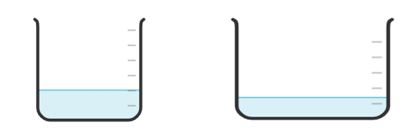
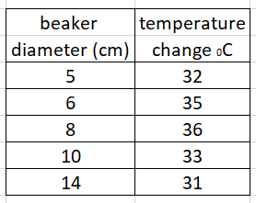
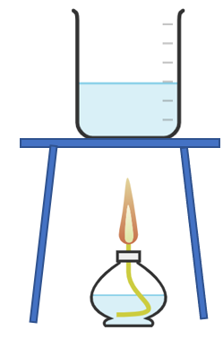 data obtained
The student’s hypothesis is ‘The greater the beaker diameter, the less heat loss’.
a. Use the headings provided to suggest likely variables for this experiment.

i. independent variable __________________________________________________ 1 mark

ii. dependent variable ____________________________________________________ 1 mark

b. For her first run, the student determines the ethanol heat of combustion to be 16.4 kJ g⁻¹. 2 marks
Explain how the student could use this figure to determine a %heat efficiency for the apparatus.

____________________________________________________________________________________

____________________________________________________________________________________

c. How can the student ensure that the method she uses will allow her to gauge the precision of her results?
1 mark
______________________________________________________________________________________

______________________________________________________________________________________

d. One of the steps the student uses in her method is to run the burner for 3.0 minutes for each trial.
i. This step could be flawed. Suggest a reason why. 2 marks

_______________________________________________________________________________________

_______________________________________________________________________________________

ii. Suggest an alternative measurement to ensure that the amount of fuel used each trial is accurately known.
1 mark
________________________________________________________________________________________

e. What conclusion do you draw from the data obtained? Justify your answer. 2 marks

_______________________________________________________________________________________

_______________________________________________________________________________________
Question 10 (8 marks)
Hydrogen peroxide is a colourless liquid. It is a bleach and an antiseptic. It decomposes slowly to water and oxygen gas. The equation for the decomposition is

2H₂O₂(l) 2H₂O(l) + O₂(g)

Manganese dioxide, MnO₂, is an inorganic catalyst for this reaction and the enzyme catalase, found in liver, is also a catalyst.

A student is asked to compare the effectiveness of MnO₂ with catalase over a range of temperatures.
a. Design an experiment to compare the reaction rate with temperature of both catalysts.
Include in your answer a description of the experimental set-up you will use and how you are going to monitor
the reaction rate. 4 marks

_______________________________________________________________________________

_______________________________________________________________________________

_______________________________________________________________________________

_______________________________________________________________________________

_______________________________________________________________________________

_______________________________________________________________________________

_______________________________________________________________________________

_______________________________________________________________________________

b. MnO₂ and catalase are both catalysts but they are different styles of catalyst. Discuss the similarities and
differences in the way they work. Include in your answer, how the performance of each catalyst is likely to
change with temperature. 4 marks

_______________________________________________________________________________

_______________________________________________________________________________

_______________________________________________________________________________

_______________________________________________________________________________

_______________________________________________________________________________

_______________________________________________________________________________

_______________________________________________________________________________

_______________________________________________________________________________

End of Exam
Mark section A: /30
Mark section B: /90
Total: /120

